BURTON BRADSTOCK SCHOOL PHOTO COMPETITION

Sponsored by BURTON BRADSTOCK ONLINE

All classes at Burton Bradstock Primary School were invited to take part in an inter-class photo competition during the Summer Term 2007 which was sponsored by Burton Bradstock ONLINE. The classes entered photographs taken in the village linked to topics they were studying in class.

Mark Stratta, the Headmaster said “The standard of entry was excellent and the school was please to take part in this community-related activity” and Susan Moores, Chair of Governors, and one of the judges, said “Class 1 was awarded the Winners Shield because the judges decided that the content of their photographs best depicted aspects of their chosen topic of ‘Growth’”. David Edwards, Burton Bradstock ONLINE Committee representative, said BB ONLINE were pleased to encourage children to work in a different medium to broaden their learning experience and the photographs will be posted on its web site (www.burtonbradstock.org.uk).



Left: Class 1 – Winners of 2007 Inter Class Photo Competition sponsored by Burton Bradstock ONLINE.

Below: Liberty Beecham receives the Winners Shield from Mr. David Edwards, Burton Bradstock ONLINE representative with left, Mrs. Susan Moores, Chair of Governors & one of the judges.
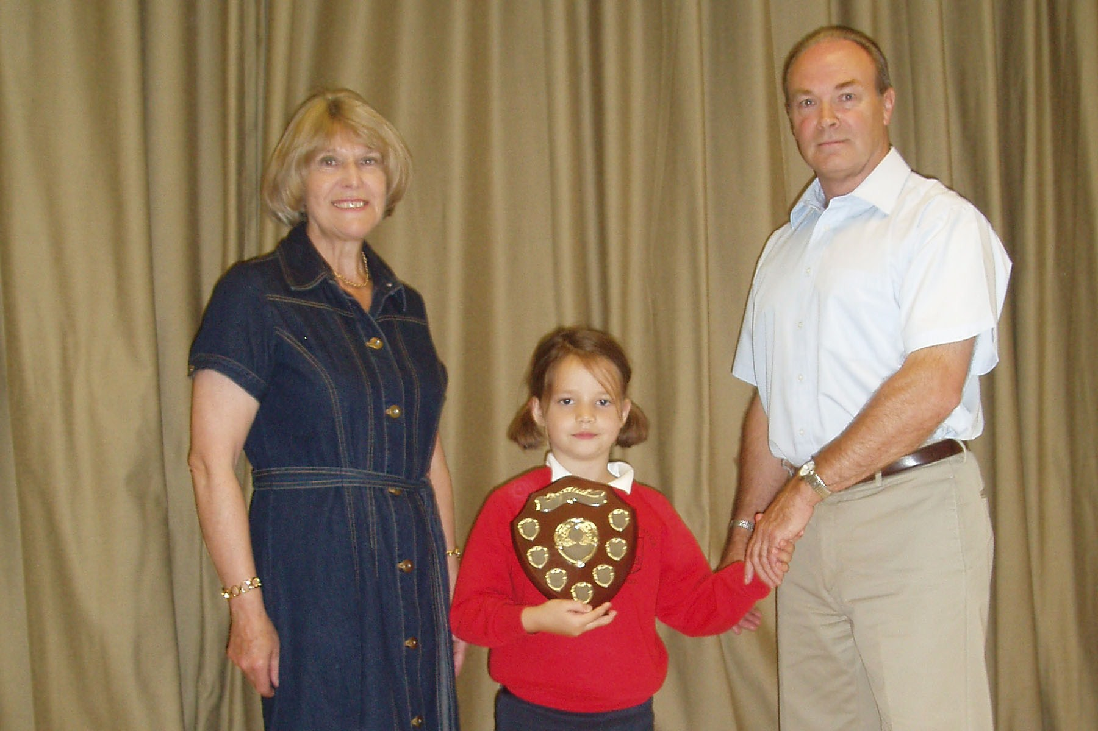
The school photograph competition runs alongside the 2007 Burton Bradstock ONLINE Digital Photo Competition, which is open to anyone anywhere.

However, if any of the children have photos from this inter-class competition that also satisfy the criteria for the under 16s class in the main digital photo competition they can, if they wish, enter them into this competition as well.

Burton Bradstock ONLINE Digital Photo Competition 2007:

How to enter? Simply e-mail (up to 10) photos to Burton Bradstock ONLINE at photocompetition@burtonbradstockonline.org.
What are the prizes? In this scheme applicants could win one of the three prizes in each category i.e.

Adults: £100, £50 and £25
Under 16s: £50, £25 and £15

Entries are now rolling in, but it isn’t too late - the deadline for entries being 16th September, 2007. Summertime is ideal for taking those all important shots – so people should be encouraged to have a go. It may even be the start of a new career? Entries will be published on the Burton Bradstock web site for all to see!


Photo from 2006 competition: Sarah Lyon

Theme:
Last year the theme of the competition was that entries should ‘evoke a sense of Burton Bradstock’ which left it wide open to interpretation. This year the theme is more specific in that the judges want it to focus on people doing things! Hence the theme is entitled

“Life in Burton Bradstock in 2007”
And the judges want to emphasise that although the competition is about activities in, or related to Burton Bradstock, the competition is open to anyone, wherever they live! They could be residents, holidaymakers or visitors from anywhere in the world!
A selection of entries may be seen on the 2007 Photogallery on the web site - we already have a few examples there, but now is the time for everyone to start clicking!!

Anyone can still be a winner!!
Full details, rules, sample entries and how to apply can be found by clicking on
www.burtonbradstock.org.uk
and following the link beneath the picture to the “2007 Photo competition”
- ENDS –

Burton Bradstock ONLINE comprises a group of villagers who created and run the village web site for locals and visitors alike, help organise computer training for villagers, run the digital photo competition and generally help & encourage people to use computers at home. The organisation has won two awards for contributions to the community.

