Burton Bradstock Online
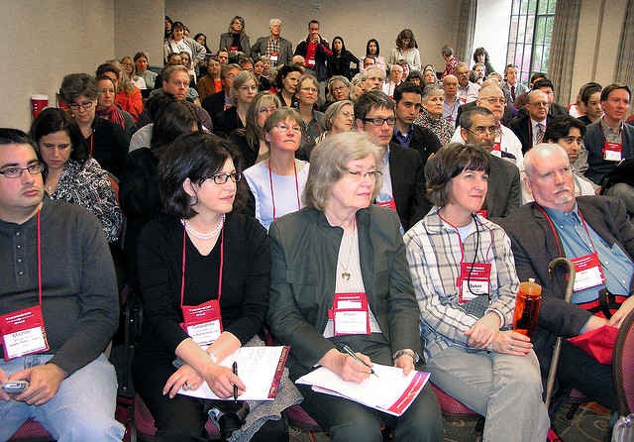
invites you to an
Open evening

in the Village Hall
7:30 p.m. on Friday, 23rd January, 2015
______________________________

You are invited to an evening where you will have the opportunity to:
- Find out about a wide range of computer courses for villagers by professional trainers

- Tell us what you would like training or help on e.g. Basic Computing, using the Internet, Internet Shopping, Skype, Smartphones, tablets, or other topics – even home visits!

- Hear tips on how to prevent criminals stealing your details, or your money online!

- Hear about the history of the village (old & recent), its smugglers, shipwrecks, WWI & WWII, pantomimes, fetes, events etc.

Wine & Nibbles

